Procedure for Investigation 1

Setting up the system  - Add your names to the top of 2 index cards. Label one “Condition B (doubling the mass)” and the other “Condition C (doubling the speed).”  - Use two pea-sized pieces of sticky putty to secure two edges of a cracker to each index card. Make sure the putty is pushed flush against the cracker and isn’t sticking out or above its face. | 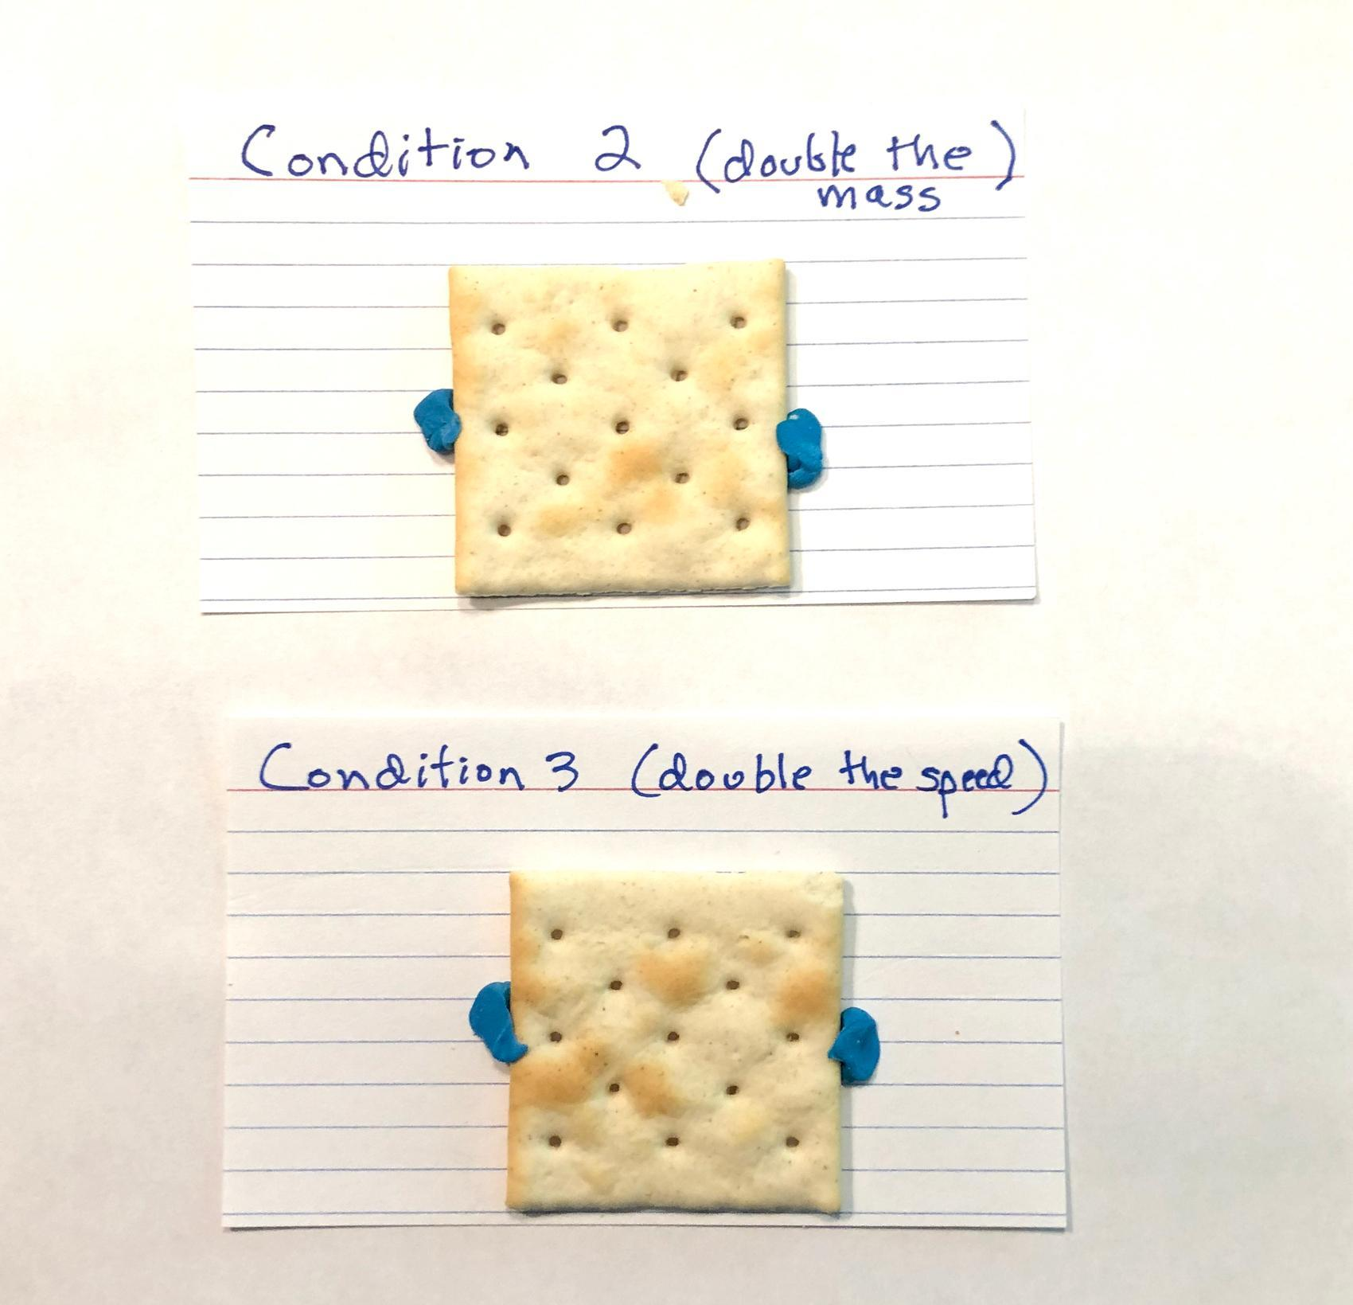
Calibrating the system for condition A (original mass and speed)
- Mass the cart and record its mass in your data table for investigation 1.
- Place a brick at the end of the track. Use a piece of tape to mark on the table the location of the brick face so you can line up the brick at this same position later.
- Hold the cart against the spring scale where it registers 5 N.  - Release the cart and time how long it takes to reach the end of the track. Repeat this a few times to confirm that your data are relatively consistent.  - Record how long it takes the cart subsystem to reach the brick. Calculate its average speed of travel in cm/sec. | 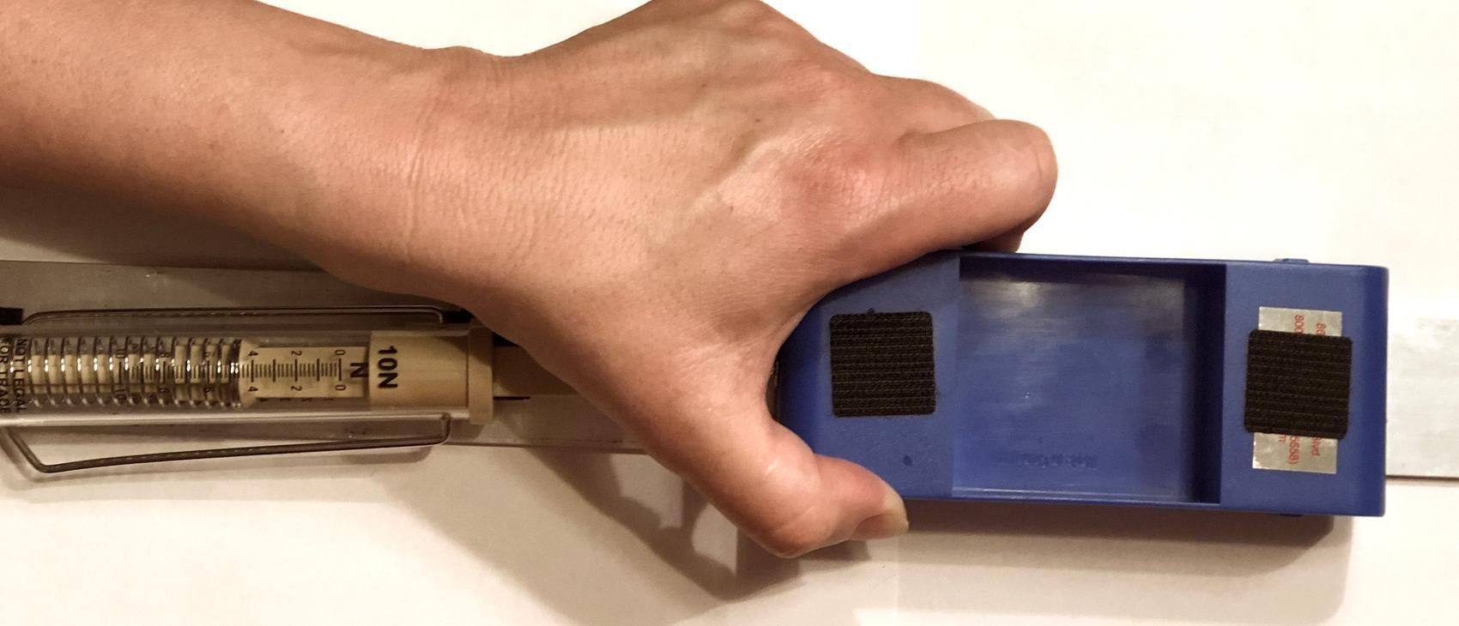
Testing the system for condition B (doubling only the mass)  - Add mass to the cart using washers, paper clips, and a piece of sticky putty to secure them in place until the total mass of the cart is double what it was in condition A.  - Hold the cart against the spring scale where it registers 7 N. This launch position should cause the heavier cart to travel at the same speed as in condition A. | 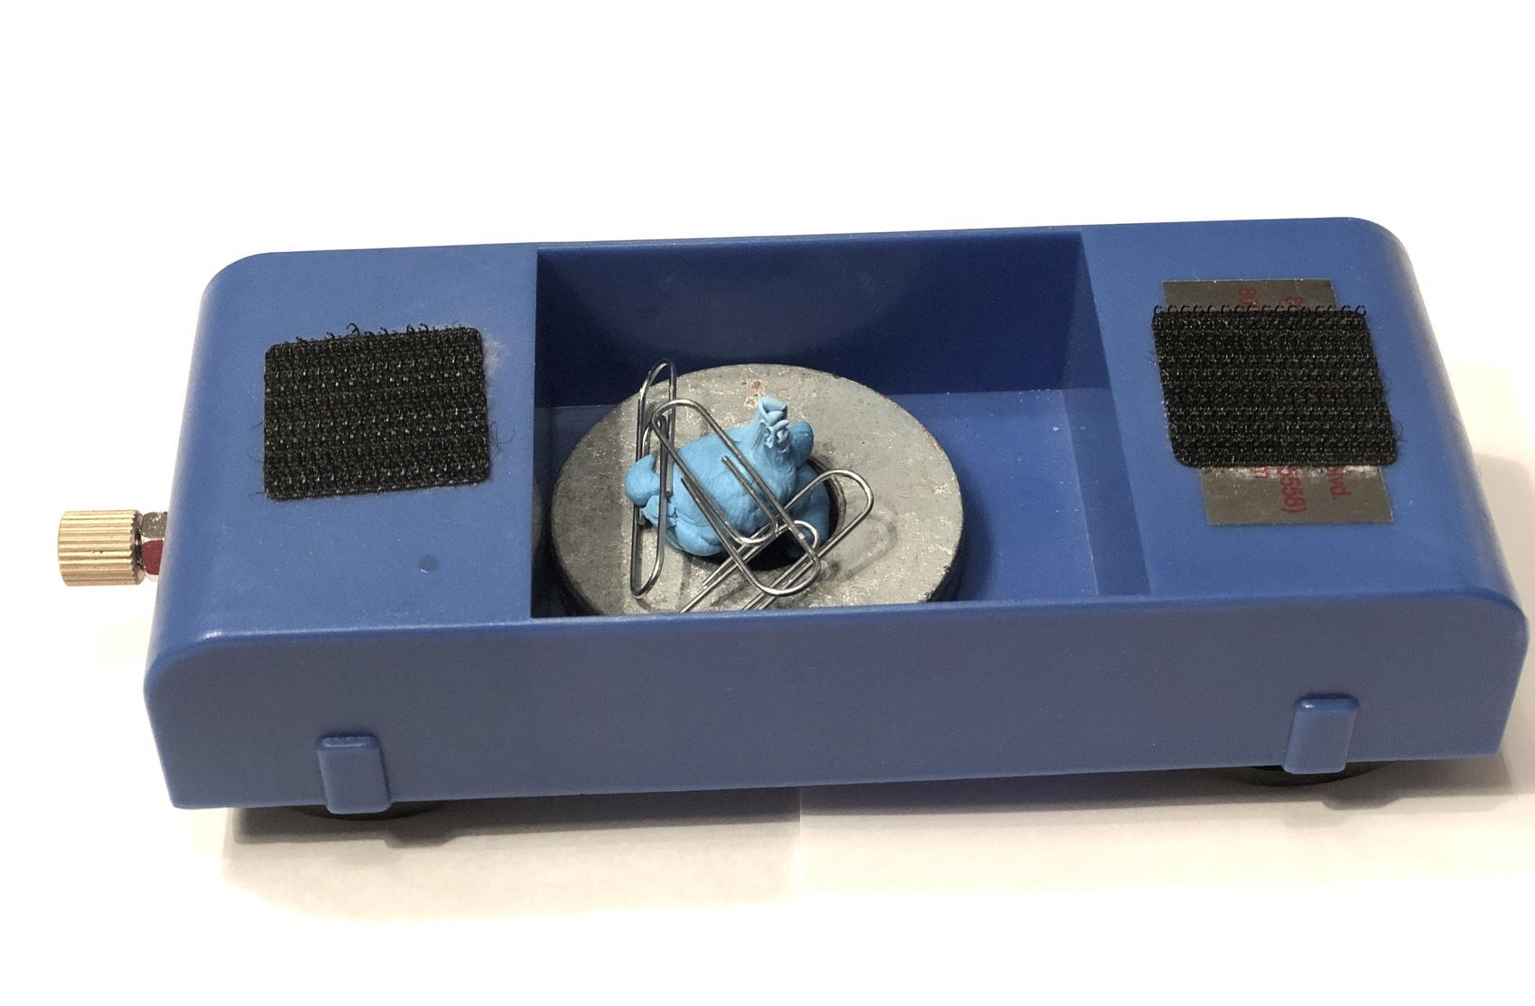
- Release the cart and time how long it takes to reach the end of the track to confirm that your data for its speed are relatively consistent and that the cart reaches the end of the track with the same speed as condition A.
- Record how long it takes the cart subsystem to reach the end of the track. Calculate its average speed of travel to confirm it is now traveling at the same speed as condition A.
- Slide a piece of paper under the end of the track and reposition the brick on top of the end of the track with a brick face perpendicular to the track where the piece of tape had marked its previous location.  - Secure an index card and cracker against the brick face using one 2-cm-long piece of tape. The cracker should face the track and its bottom edge should be next to or on the track.  - Launch the cart from the same launcher force position (7 N) as in step 10. The resulting collision with the cracker will damage it. | 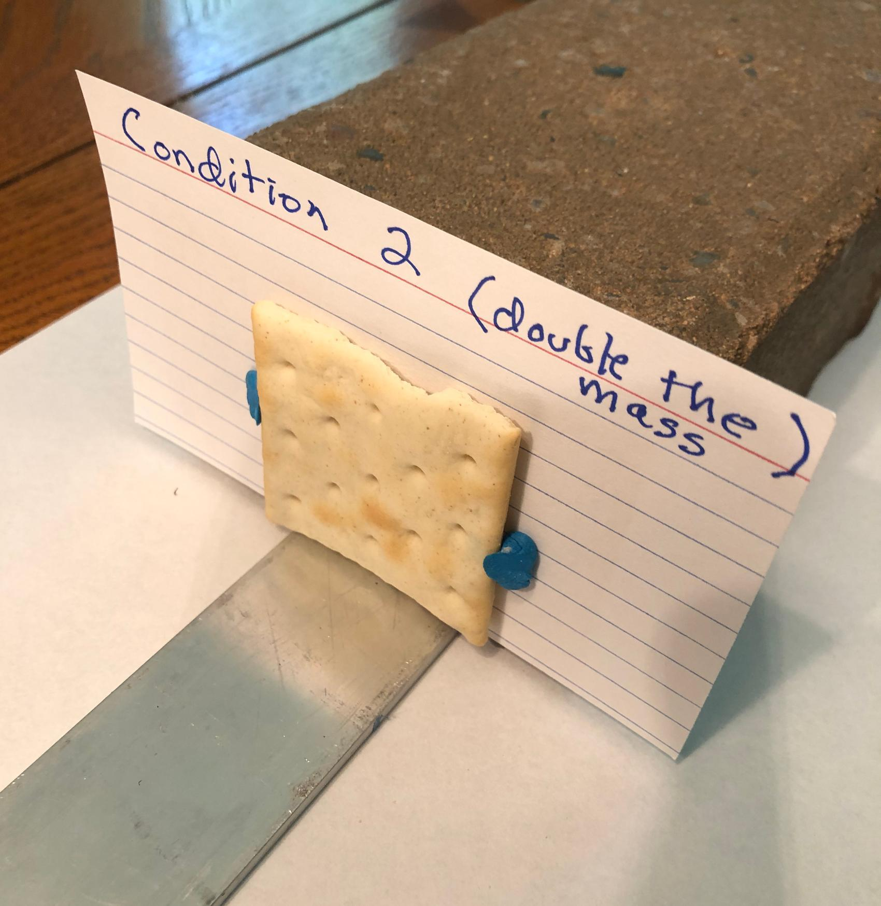
- Carefully remove the index card from the brick. Remove the brick from the end of the track and slide the paper out from under it.
- Place the index card and cracker on the paper. Brush all crumbs on the track on to the paper and then set aside the paper, index card, and cracker in a safe place in your work area so it will not be disturbed when testing the next condition

Testing the system for condition C (doubling only the speed)
- Remove all the weights and sticky putty you added to the cart in condition B and remass the cart to confirm it has returned to the original mass it was in condition A.
- Hold the cart against the spring scale where it registers 10 N. This launch position should cause the cart to travel down the track twice as fast as in condition A or condition B.
- Release the cart and time how long it takes to reach the end of the track to confirm that your data for its speed are relatively consistent and that the cart reaches the end of the track with double the speed as condition A.
- Slide a piece of paper under the end of the track and reposition the brick on top of the end of the track with a brick face perpendicular to the track where the piece of tape had marked its previous location.  - Secure a new index card and cracker against the brick face using one 2-cm-long piece of tape. The cracker should face the track.  - Launch the cart from the same launcher force position (10 N) as in step 19. The collision with the cracker will damage it. | 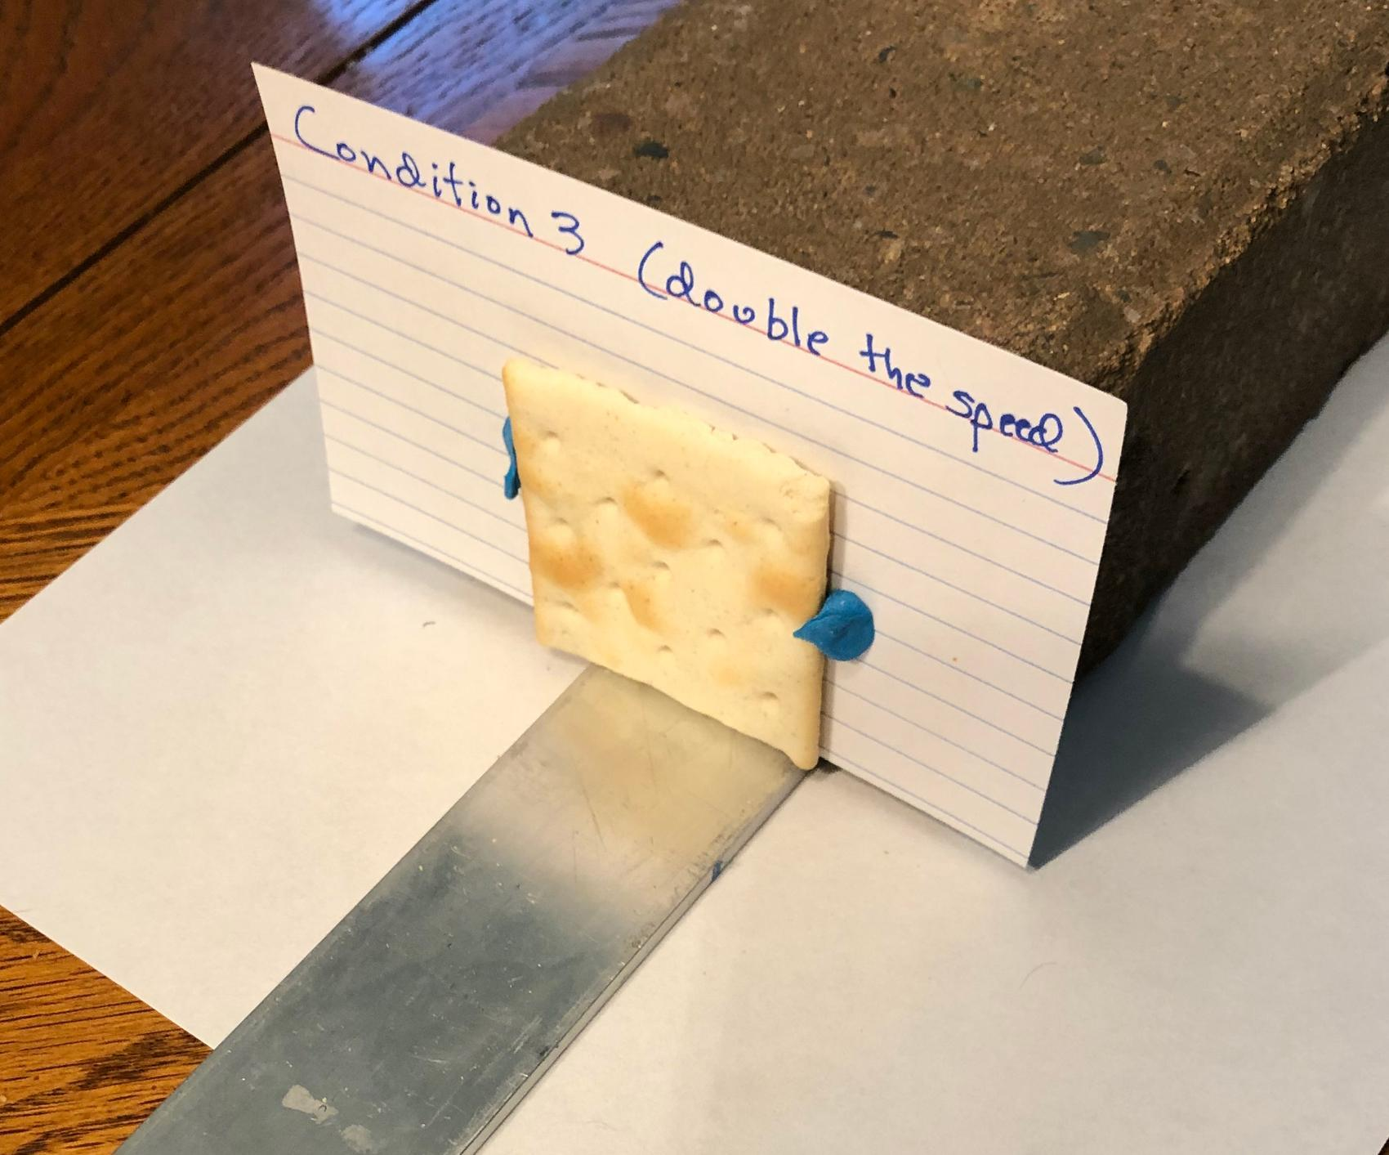
- Carefully remove the index card from the brick. Remove the brick from the end of the track and slide the paper out from under it.
- Place the index card and cracker on the paper. Brush all crumbs on the track onto the paper and then set aside the paper, index card, and cracker in a safe place in your work area so it will not be disturbed when testing the next condition.

Pooling the whole-class results and analyzing the results
- Carefully transfer each paper and index card with the damaged cracker and debris on it to the area indicated by your teacher for pooling all the class results together.

